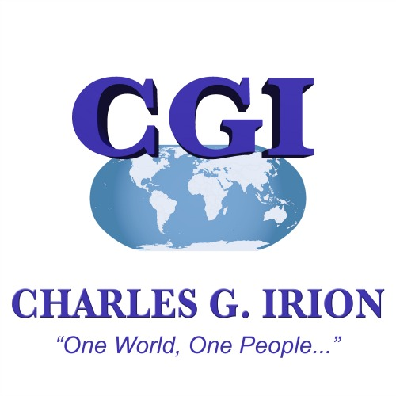 Charles G. Irion, Author and Entrepreneur
___________________________________________________________________________________

FOR IMMEDIATE RELEASE

Media Contact:
Jennifer L. Howell
Jennifer@IrionBooks.com

Charles G. Irion, author of the Summit Murder Mystery Series to host an evening of mystery and intrigue.
Live interactive Murder Mystery Dinner party at the beautiful Hyatt Regency Scottsdale, Gainey Ranch, in Scottsdale, Arizona will be a “Launch Event” for author’s new book, Murdered by Gods
Accomplished author, Charles G. Irion has written a new book, Murdered by Gods and it’s creating massive buzz and intrigue! An exciting high-tech adventure in which famous mountaineer and secret agent, Scott Devlon, takes the reader through the jungles of Peru and onto the mystical ruins of Machu Picchu. Why? In search of a ruthless killer, of course.
Irion has commissioned Murder Ink Productions; a local entertainment company based in Arizona since 1989, to adapt his thrilling book into a live interactive murder mystery play in which invited guests will actually act out Irion’s penned characters whilst being lead by Murder Ink’s troupe of professional actors to solve the intricate mystery.
In keeping with the philanthropy efforts that Irion holds dear, this epic event will also benefit Project C.U.R.E. (Commission on Urgent Relief and Equipment) an international non-profit medical relief organization for developing countries founded in 1987 by James Jackson. Project C.U.R.E. CEO and son of founder James Jackson, Dr. Doug Jackson will join Irion for the new book launch party and benefit event along with other philanthropists from all over the globe.
Irion has carefully crafted an evening of mystery, romance and art at the splendid Hyatt Regency’s five star restaurant “Alto” providing the perfect setting for an evening of intrigue to enhance the murder mystery dinner book launch party to include a celebrated three course meal, private dining room and Gondola Rides, and some many more surprises.
Irion is also an accomplished painter and will be showing his collection of paintings that run the gambit of abstract to real life most of which has been inspired by his adventurous globetrotting and mountaineering. “My paintings capture both the visual and spiritual essence of my feelings of what I experienced at the moment of the journey, in a way that a photograph can’t.” Says Irion as he humbly reflects his impressive body of work. Irion’s art will available for purchase during the launch party with all proceeds being donated to Project C.U.R.E.
“I am very excited about the new book and the launch party. It’s sure to be a memorable evening of mystical delights for all while giving back to a great cause.”
Irion’s book “Murdered by Gods” was inspired while joining K2 Adventures Foundation on his relief trip to Peru as he and his team visited the spectacular cities of Lima, Cusco, and Aguas Calientes. Including guided tours of the historic city of Cusco, and a six-day hike to reach the ancient city Machu Picchu, Irion was clearly in his element. No stranger to mountain climbing after his climbs up Mt. Everest in 1987, and Mt. Kilimanjaro in 2011.
Irion will surely create a world-class adventure in Scottsdale, Arizona and there is no doubt fans of the Summit Murder Mystery Series will be captivated by his new book, “Murdered by Gods.”
“It’s a thrilling adventure spawned from the collision of modern technology and ancient mythical practices!” Irion advises with a sparkle in his eyes.

